## **Project Specification Document**

### 

### **Project Title: LockedMe.com**

### **Developer Details:**

* **Name:** Shoumik Lodh
* **Role:** Full Stack Developer
* **Company:** Company Lockers Pvt. Ltd.

### **Product Overview:**

LockedMe.com is a prototype application aimed at digitizing the product management for Company Lockers Pvt. Ltd. The application provides a command-line interface for file management operations such as retrieving, adding, deleting, and searching files in a directory. This prototype will serve as a proof of concept for stakeholders to secure budget approval for further development.

### **Core Capabilities:**

1. **Returning File Names:** Display all file names in the directory in ascending order.
2. **File Operations:**
   * **Add a File:** Add a specified file to the directory.
   * **Delete a File:** Delete a user specified file from the directory.
   * **Search a File:** Search for a user specified file in the directory.
3. **Navigation:**
   * Return to the main menu from any sub-menu.
   * Exit the application.

### **User Interactions:**

* Command-line interface for input and output.
* User-friendly prompts and messages.
* Case sensitivity handling for file operations.

### **Application Flow:**

1. **Welcome Screen:**
   * Display application name and developer details.
   * Present main menu options to the user.
2. **Main Menu Options:**
   * Option 1: Retrieve current file names in ascending order.
   * Option 2: Display file operation menu.
   * Option 3: Exit the application.
3. **File Operation Menu:**
   * Option 1: Add a file.
   * Option 2: Delete a file.
   * Option 3: Search a file.
   * Option 4: Return to the main menu.

### **Sprint Planning:**

The project will be divided into three sprints over 15 working days (3 weeks).

#### **Sprint 1: (Week 1)**

* **Setup:**
  + Initialize the Git repository.
  + Set up the project structure in Eclipse/IntelliJ.
* **Development:**
  + Implement the welcome screen.
  + Develop the main menu interface.
* **Documentation:**
  + Create initial project documentation and flowcharts.

#### **Sprint 2: (Week 2)**

* **Development:**
  + Implement the functionality to retrieve file names in ascending order.
  + Develop file operation menu.
  + Implement add and delete file functionalities.
* **Testing:**
  + Perform unit testing for implemented features.
* **Documentation:**
  + Update documentation with algorithms and core concepts.

#### **Sprint 3: (Week 3)**

* **Development:**
  + Implement search file functionality.
  + Add exception handling and input validation.
* **Testing:**
  + Perform integration testing.
  + Fix any identified issues.
* **Documentation:**
  + Finalize documentation with sprint details and GitHub repository link.

### **Java Concepts:**

* **Exception Handling:** To manage errors and invalid inputs.
* **Collections:** To store and manage file names.
* **Sorting:** To display file names in ascending order.
* **File I/O:** To handle file operations.

### **Data Structures and Algorithms:**

* **ArrayList:** For storing file names.
* **Sorting Algorithm:** Using Java's Collections.sort() for sorting file names.
* **Search Algorithm:** Linear search for finding files.

**Flowchart:**

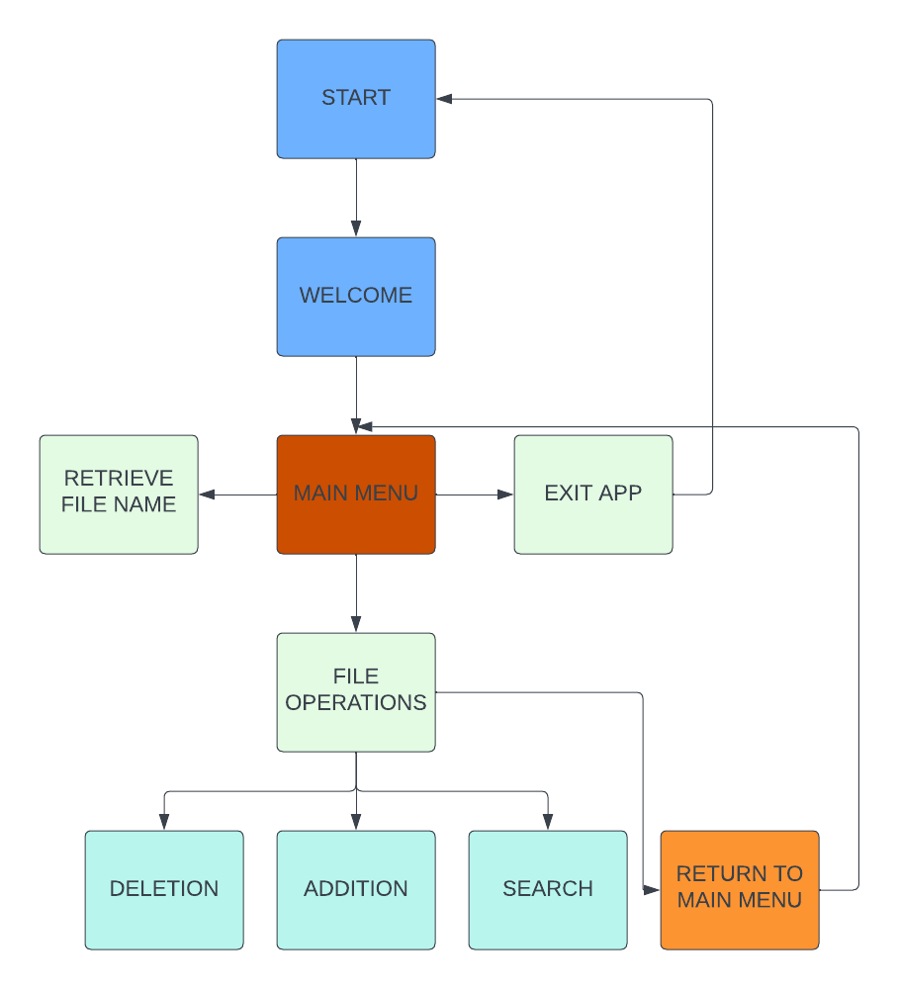  
**Github link:** [**https://github.com/ShoumikLodh/Virtual-Key-for-Your-Repositories**](https://github.com/ShoumikLodh/Virtual-Key-for-Your-Repositories)